

SEMESTER PROJECT REPORT

Presented to

Ma’am Tajwar Mehmood

In partial fulfillment
of the requirement for the course of

“Data Structures CS-2001”

By

Talha Khurram 22I-0790

CS-2001 DATA STRUCTURES
BSCS SPRING 2024
FINAL PROJECT REPORT

- TABLE OF CONTENTS:

CONTENTS | Page No.
- Game interface | 3
- Objectives and Introduction  - Introduction of the problem statement  - Objectives | 4
- Contributions of the members | 5
- C++ Code Explanation  - AVL Implementation & Balancing  - Maze Generation (Including Randomization)  - Shortest Path Finding Algorithm  - Combat System  - Inventory Management with AVL  - Reward Placement & Collection  - High Score File Handling | 5

GAME INTERFACE
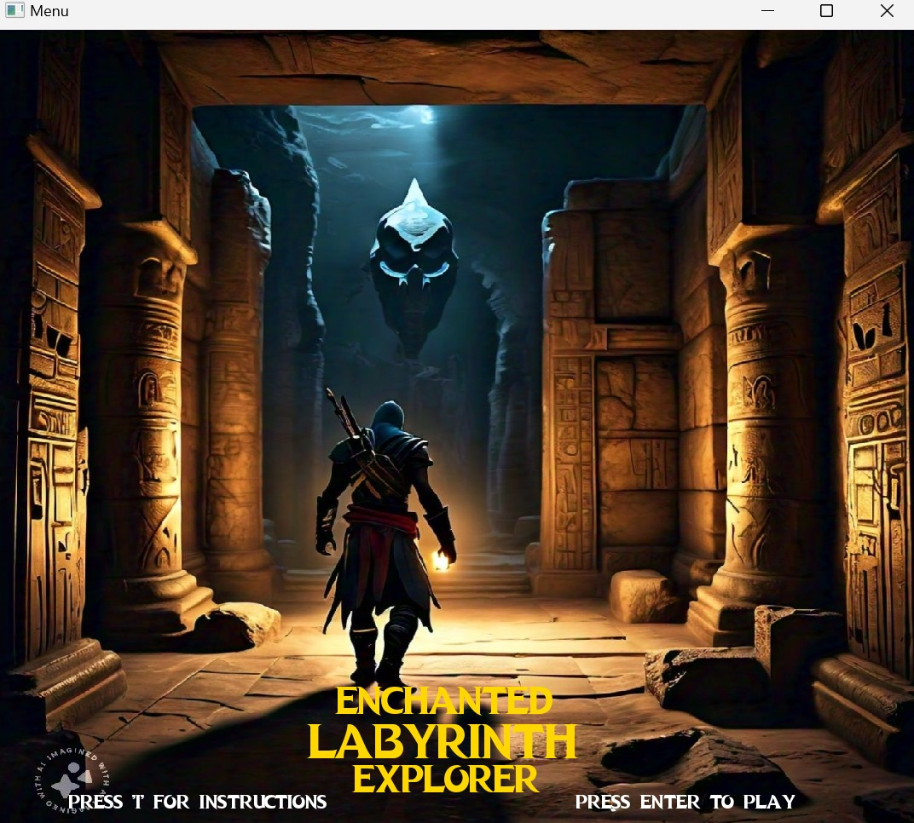
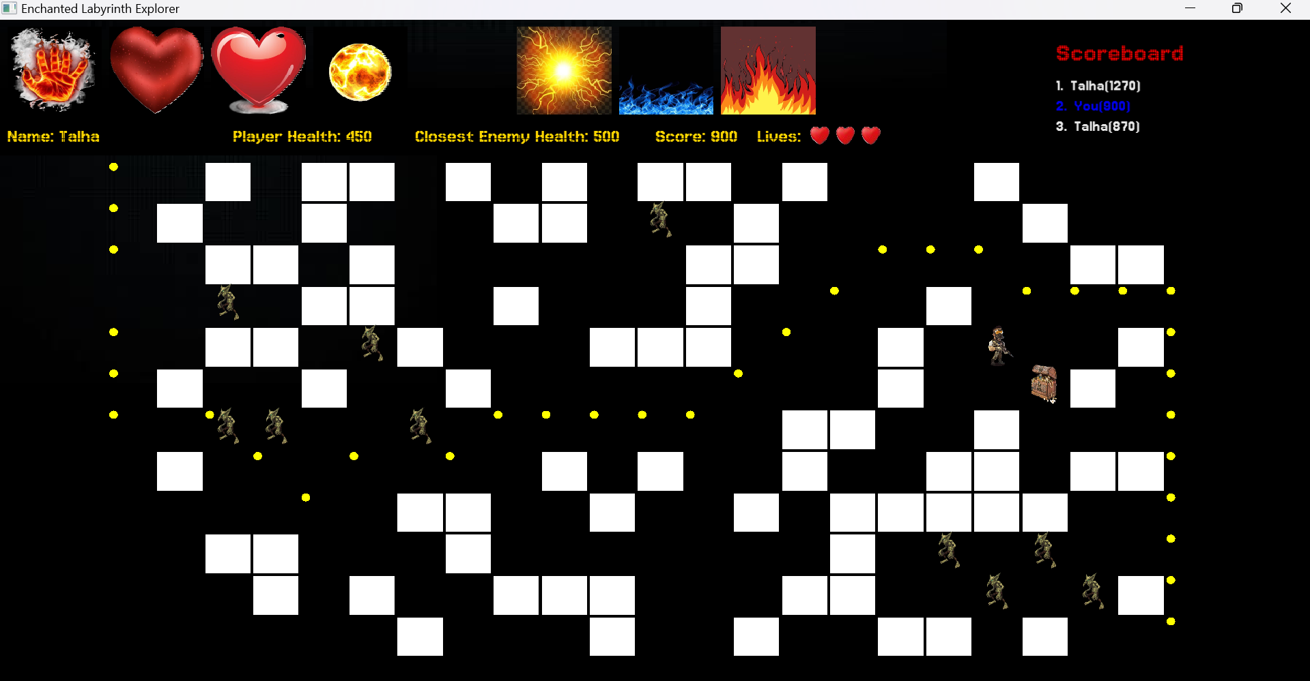
- OBJECTIVES AND INTRODUCTION:
Introduction of the problem statement:
Welcome to the mystical realm of Arcadia, where an ancient labyrinth lies shrouded in mystery and danger. Known as the Enchanted Labyrinth, this intricate maze is said to conceal untold treasure guarded by magical creatures and hidden traps. Brave adventurers are called upon to embark on a quest to navigate through the labyrinth's twisting passages, employing wit, courage, and strategic thinking to overcome its challenges and claim its riches.
In the realm of Arcadia, the Enchanted Labyrinth awaits, promising treasures and challenges. Are we ready for a quest where wit, courage, and strategy are key?

Objectives:
- Embark on a quest through the Enchanted Labyrinth to uncover untold treasures and face thrilling challenges.
- Implement an AVL Tree for efficient Inventory Management to organize and balance collected treasures.
- Design a dynamic Maze Generation Algorithm to create randomized paths, dead-ends, and obstacles within the labyrinth.
- Utilize Shortest Pathfinding Algorithms to navigate through the labyrinth's complex layout from entrance to exit.
- Engage in strategic battles with mythical creatures and magical guardians using honed combat skills and managed inventory.
- Enhance the Reward System by adding rare and legendary treasures, each offering unique abilities and bonuses.
- Navigate the labyrinth with an immersive User Interface providing real-time feedback on progress, inventory, and encounters.

- CONTRIBUTION OF THE MEMBERS:
MEMBERS | CONTRIBUTIONS
Talha Khurram | AVL implementations, Maze generations,File Handling/Highscores
Sarim Rasheed | Game Interface, Sounds, Combat System
Umama Bajwa | Shortest path, Rewards/Treasures, Report

- C++ Code Explanations:
- AVL Implementation & Balancing:
Node Class:
- Represents a node in the AVL tree.
- Contains data members for value (`val`), left and right child pointers (`left`, `right`), and height (`height`).
- Provides constructors to initialize the node.

AVL Class:
- Represents the AVL tree data structure.
- Contains a pointer to the root node (`root`).
- Provides a constructor to initialize the AVL tree.

Insert Function:
- Inserts a new node with the given value into the AVL tree.
- Maintains the balance of the tree by performing rotations if necessary.

ComputeHeight Function:
- Calculates the height of a node in the AVL tree recursively.
- Used during insertion to update the height of nodes.

Inserting Function:
- Recursive helper function for inserting a new node into the AVL tree.
- Performs the actual insertion and updates node heights.
- Handles balancing of the tree by calling rotation functions
RightRotate Function:
- Performs a right rotation on a given node to maintain AVL balance.
- Updates heights of affected nodes after rotation.

LeftRotate Function:
- Performs a left rotation on a given node to maintain AVL balance.
- Updates heights of affected nodes after rotation.

GetHeight Function:
- Calculates and returns the height of a given node.
- Returns -1 if the node is nullptr.

Preorder Function:
- Traverses the AVL tree in preorder fashion to print nodes at a specified level.
- Used for debugging and visualization purposes.

DeleteNode Function:
- Deletes a node with the given value from the AVL tree.
- Handles various cases including leaf nodes, nodes with one child, and nodes with two children.
- Maintains AVL balance after deletion.

HelpDel Function:
- Recursive helper function for deleting nodes.
- Reinserts child nodes of the deleted node into the AVL tree to maintain balance.

Print Function:
- Prints the AVL tree level by level.
- Calls the preorder function for each level.

Balanced Function:
- Calculates the balance factor of a given node (height of left subtree - height of right subtree).

sBalanced Function:
- Prints the balance factor of the root node.
- Useful for checking AVL tree balance after insertions and deletions.
- Maze Generation (Including Randomization):

The code snippet introduces a class named Maze, which serves as the foundation for creating and rendering a maze environment within a game. It includes functionalities to initialize maze dimensions, textures, shapes, and colors. The constructor sets up the maze by generating blocks, determining their validity, and establishing coordinates. The drawMaze function is responsible for rendering the maze onto the game window, including background, inventory, and high score panels, along with maze blocks. Additionally, helper functions like getWallSprite and isValid aid in accessing specific maze elements and checking their validity. Overall, this code snippet establishes the groundwork for implementing a maze-based game with interactive features.

Maze Class:
- Represents the maze environment for the game.
- Contains textures, shapes, and colors used to create the maze.
- Manages the generation and drawing of the maze.

Data Members:
- walls_texture_horizontal and walls_texture_vertical: Textures for horizontal and vertical walls in the maze.
- blocks and foods: Arrays of RectangleShape objects representing maze blocks and food items.
- playerColors: Array of Color objects representing player colors.
- verticalLineGap and horizontalLineGap: Integers representing the gap between lines in the maze.
- n and m: Integers representing the dimensions of the maze.
- walls_sprite: 2D array of Sprite objects representing maze walls.
- valid: 2D array of integers representing the validity of maze blocks.
- coords: 3D array of integers representing the coordinates of maze blocks.

Constructor:
- Initializes data members including textures, colors, gaps, dimensions, arrays, and coordinates.
- Populates maze blocks and determines the validity of each block.

DrawMaze Function:
- Draws the maze environment onto the render window.
- Draws background, inventory, and high score panels.
- Draws maze blocks based on their validity.

GetWallSprite Function:
- Returns a reference to the Sprite object representing a wall at the specified coordinates.

IsValid Function:
- Checks if the specified coordinates are within the bounds of the maze and represent a valid block.

- Shortest Path Finding Algorithm (A* Used):
A* (A-star) algorithm efficiently finds the shortest path from a starting point to a goal by prioritizing nodes for exploration based on the sum of the cost to reach the node from the start (g) and an estimated cost from the node to the goal (h). This combined cost guides the search towards the goal, ensuring that nodes closer to the goal are explored first. A* terminates when the goal is reached, reconstructing the shortest path by tracing back through the parent pointers stored in each node.

Initialization:
- A priority queue obj of type MyPriorityQueue<Node*> is created to store nodes to be explored. The priority queue ensures that nodes with lower estimated cost (heuristic + cost from start) are explored first.
- A 2D array closed is created to mark visited nodes. Initially, all nodes are marked as unvisited (false).
Start Node Creation and Addition:
- The start node with coordinates startX and startY is created with a cost from the start of 0 and a heuristic estimate to the goal.
- The start node is added to the priority queue obj.
Main Loop:
- The main loop continues until either all nodes are explored or the goal node is found.
- In each iteration, the node with the lowest estimated total cost (f()) from the priority queue obj is retrieved.
Goal Check:
- If the retrieved node is the goal node (goalX, goalY), the function exits, and the path is reconstructed.

Node Exploration:
- The neighbors of the current node are explored. This includes all adjacent cells, including diagonals.
- For each neighbor, the following steps are performed:
- Check if the neighbor is within the bounds of the maze and is unvisited.
- If the neighbor is a valid move (not blocked by walls), calculate the tentative cost to reach the neighbor from the start node.
- Create a new node representing the neighbor with the tentative cost and heuristic estimate.
- Add the neighbor node to the priority queue obj.
- Mark the neighbor as visited by updating the closed array.
- Path Reconstruction:
- If the goal node is found, the path is reconstructed by following the parent pointers from the goal node to the start node.
- The reconstructed path is returned as an array of Node*.

Heuristic Function:
- The heuristic function heuristic calculates the Manhattan distance between two points (x1, y1) and (x2, y2). This is an admissible heuristic for grid-based pathfinding and provides a lower bound on the actual cost to reach the goal.

Priority Queue Comparator:
- The compareNodes function defines the comparison criteria for the priority queue. It ensures that nodes with lower total cost (f()) are prioritized for exploration.

Shortest Path Identification in the maze:
- Once the A* algorithm finds the shortest path in the maze, it identifies the nodes along this path.
- Yellow circles (CircleShape) are used to visually mark the nodes on the shortest path.
- Each circle is drawn at coordinates that correspond to the positions of the nodes within the maze grid.
- These circles are then drawn onto the maze grid in the graphical window, overlaying the existing maze layout.
- highlighting the path with distinct yellow circles, users can easily discern the optimal route amidst the maze's layout.
- This visual cue aids users in navigating the maze, providing clear direction towards the goal
- Combat System:

The combat system in the game revolves around strategic movement, projectile creation, and health management to overcome enemies and navigate the maze successfully. Players must maneuver through the maze, dodging obstacles and enemy fire while strategically positioning themselves to attack. Both the player and enemies can create fire projectiles to inflict damage, requiring players to be vigilant in avoiding incoming attacks while aiming their own. Effective health management is crucial, as sustaining damage from enemy fire reduces the player's health, and reaching zero health results in losing a life. Players must balance offense and defense, utilizing their surroundings and available resources to defeat enemies and collect treasures while aiming to achieve a high score and progress through the game.

Initialization:
- The game initializes with a maze, player, enemies, and treasures.
- Player's health is set to 500, and enemies have a health of 500.
Player Movement:
- The player can move up, down, left, or right within the maze.
- Player movement is restricted by maze boundaries and obstacle placement.
Enemy Movement:
- Enemies move randomly within the maze, with a chance of movement determined by a random count.
- Enemy movement is limited by maze boundaries and obstacles.

Fire Creation:
- Both the player and enemies can create fire projectiles to attack each other.
- Fire projectiles are created in the direction the player or enemy is facing.
- Each fire projectile has a limited number of moves before disappearing.
Fire Collision Detection:
- Fire projectiles collide with obstacles, walls, or the opposing player/enemy.
- When a fire projectile collides with an enemy or player, it inflicts damage to their health.
- If a fire projectile collides with an obstacle or wall, it disappears.
Health Management:
- Player and enemy health is reduced when hit by fire projectiles.
- If the player's health reaches zero, they lose a life, and their health is reset.
- If an enemy's health reaches zero, it is defeated, and the player earns points.
Combat Strategy:
- The player can strategically position themselves to avoid enemy fire and attack enemies.
- Enemies move randomly but can also fire projectiles at the player.
- Both the player and enemies aim to reduce each other's health while avoiding incoming fire.
- When the player is 5 or 7 blocks away from an enemy, pressing the space bar generates fire projectiles directed towards the enemy.
- Conversely, when an enemy is three blocks away from the player, it generates fire projectiles aimed at the player.
Reward System:
- Defeating enemies rewards the player with points and may unlock treasures in the maze.
- Treasures can provide bonuses such as health restoration or additional points.
Game Over Condition:
- The game ends when the player loses all lives, indicated by reaching zero health multiple times.
- The player can try to achieve a high score by defeating enemies and collecting treasures before losing all lives.

- Inventory Management with AVL

Treasure Class:
- Represents individual treasures.
- Attributes include position, health, visibility, and a pointer to the next treasure.
- Randomly assigned reward values and loaded with texture images.
- Methods include set_position to position the sprite and draw to render it.

Treasure List Class:
- Manages a linked list of treasures.
- Contains a pointer to the start of the list.
- Methods include insert to add new treasures and create to generate multiple treasures.

Keypress Activation:
- Rewards linked to specific keypress events.
- Enables quick activation during battles.

Persistent Visibility:
- Rewards remain visible post-collection.
- Ensures players are aware of available bonuses.

Strategic Utilization:
- Players activate rewards with corresponding keys.
- Offers tactical options during combat.

Inventory System:
- Treasures stored as nodes in an AVL tree.
- Successful retrieval and deletion of treasures ensure efficient management.

- Reward Placement & Collection

Treasure Generation:
- Treasures are initialized within the maze upon game start.
- Each treasure instance is assigned a random reward value and corresponding texture image.
- Random placement within the maze ensures varied and unpredictable treasure locations.
Placement within Maze:
- Coordinates for each treasure are determined based on maze dimensions and obstacle placement.
- Placement avoids obstacles and ensures accessibility to players.
- Randomization adds challenge and excitement to gameplay.

Treasure Collection:
- Player interaction triggers treasure collection.
- When the player's position matches a treasure's position, it's considered collected.
- Rewards from collected treasures are activated and displayed for the player to use.

Reward Activation:
- Collected rewards are activated by corresponding keypress events.
- Activation provides immediate benefits during gameplay, such as score increase or extra lives.

Visual Feedback:
- Collected treasures become invisible to indicate collection.
- Active rewards are visually displayed on the game screen for player reference and utilization.

- File Handling for high score display:
Score Body Structure:
- Represents an individual score entry in the list.
- Contains the player's score, name, and a pointer to the next entry.

Score List Class:
- Manages the list of score entries.
- Includes methods for inserting new scores, reading from/writing to a file, sorting the list, and printing scores.

Insertion and Sorting:
- New scores are inserted at the end of the list, maintaining its order.
- The list is sorted in descending order based on scores using the bubble sort algorithm.

File I/O Operations:
- Reads scores from the "scores.txt" file, populating the list with entries.
- Writes sorted scores back to the file after any changes.

Printing Scores:
- Displays the scores and associated player names to the console for visualization.

Displaying Top 3 Scores:
- Initializes coordinates x and y for displaying scores on the screen.
- Iterates through the top three scores stored in the highscore list.
- If the player's score is among the top three and hasn't been displayed yet (done_display is false), it's highlighted in blue.
- Constructs a string scoreText representing the score entry.
- Sets the text color to blue if the player's score is being displayed; otherwise, it remains white.
- Updates the text object with the score information and sets its position.
- Draws the text on the game window.

